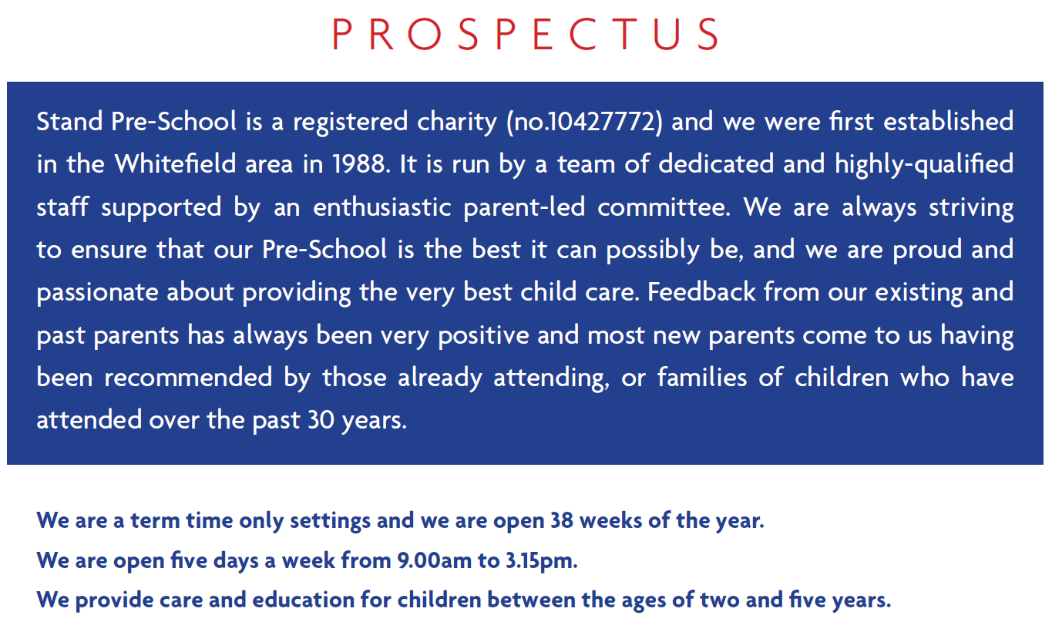
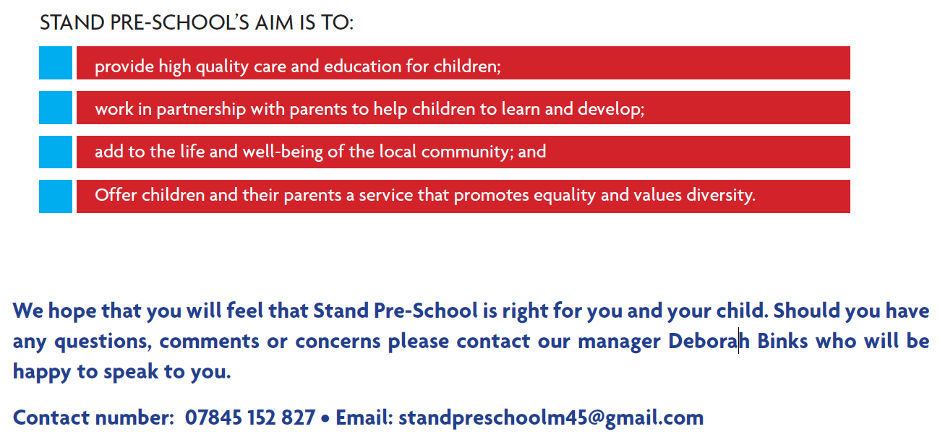

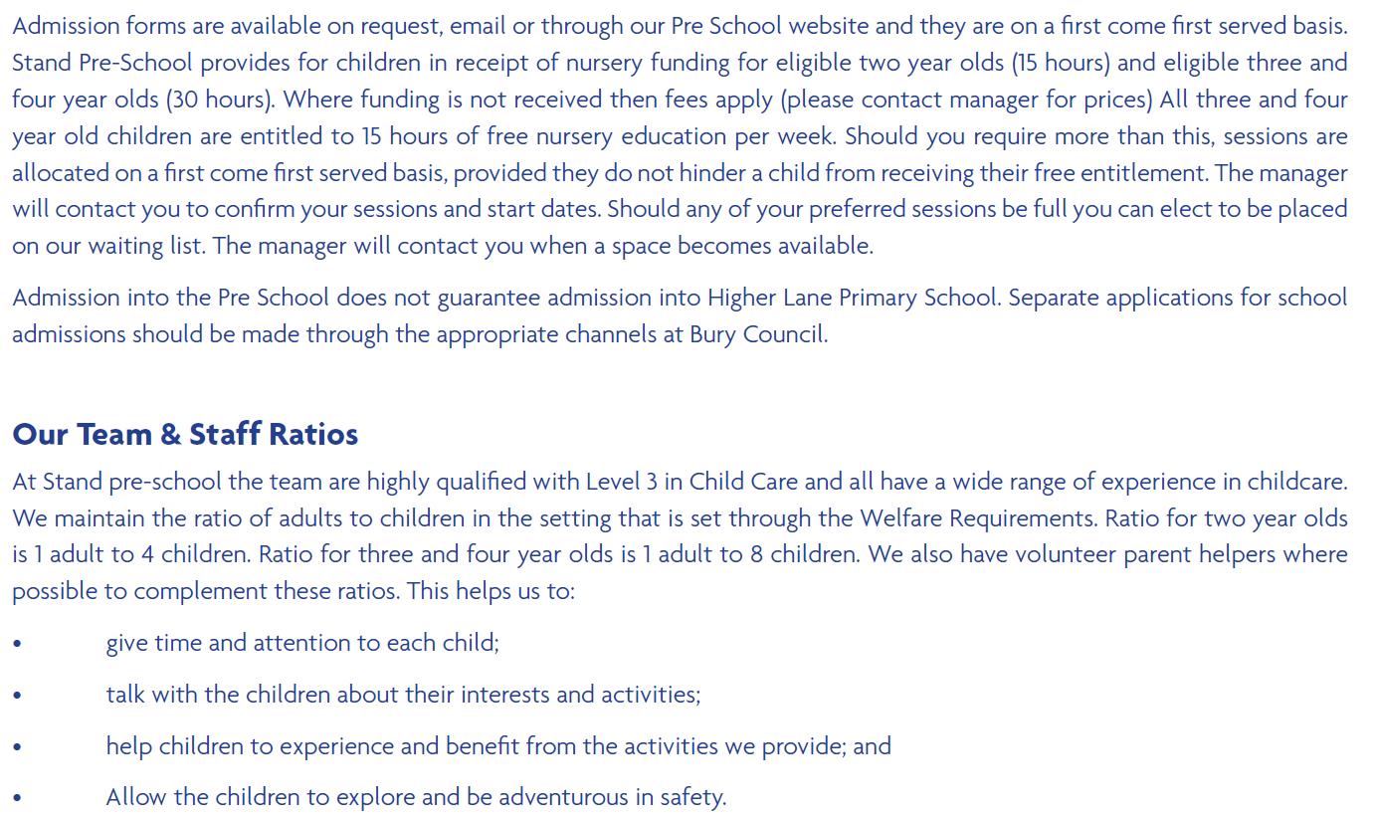
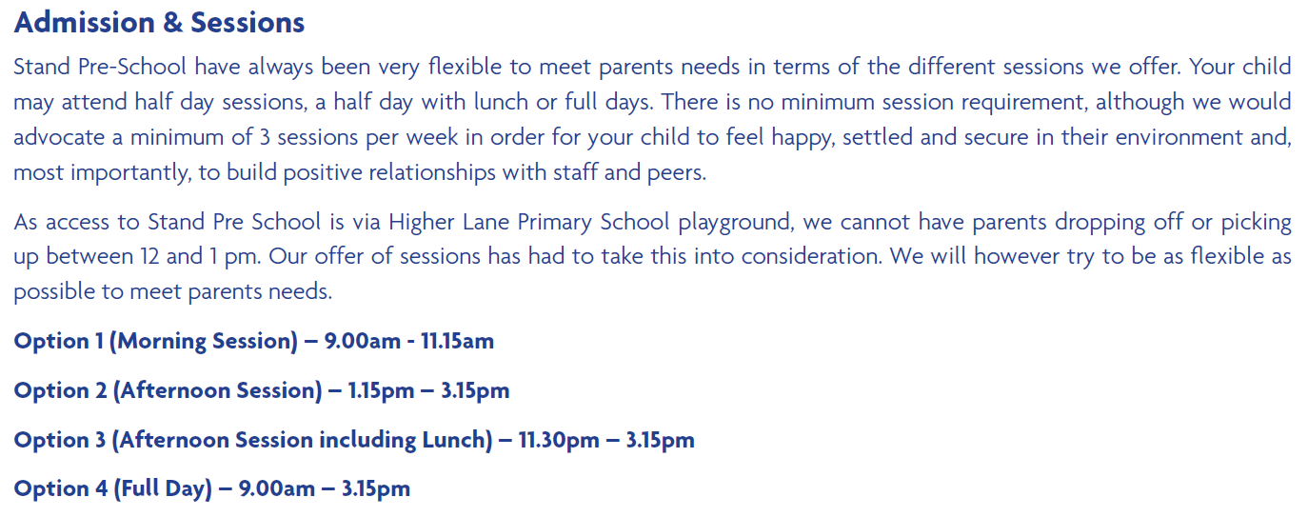

NAME | JOB TITLE | QUALIFICATIONS
Deborah Binks | Pre-School Manager  SENCO | Level 3 Diploma in Childcare and Education.  Level 2 in Leadership & Management
Carol Dunn | Deputy Manager  Room Leader  Designated Safeguarding Officer | NVQ Level 3 in Childcare and Education for Early Years.
Joanne Beaumont | Pre-School Practitioner  Behavioural Leader | NVQ 3 in Children’s and Young People’s Workforce
Susan Cleary | Pre-School Practitioner  Health & Safety Officer | NVQ 3 in Children Care, Learning and development
Claire Ball | Pre-School Practitioner | NVQ 2 in Children’s and Young People’s Workforce
Christine Phillipson | Pre-school Practitioner | NVQ 2 in Childcare and Education for Early Years
