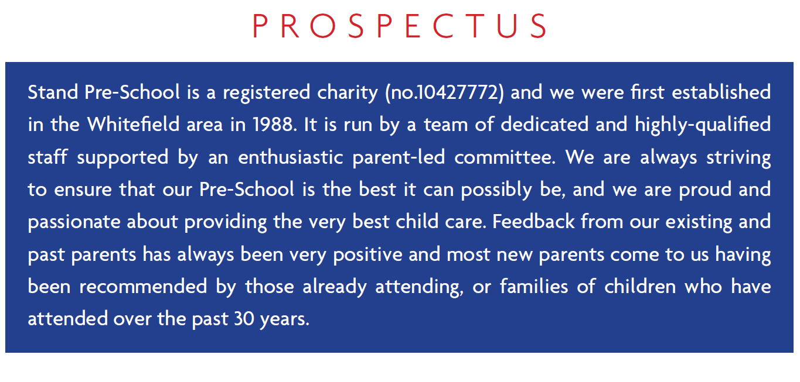
We are a term time only setting and we are open 38 weeks of the year.
We are open five days a week from 9.00am – 3.30pm
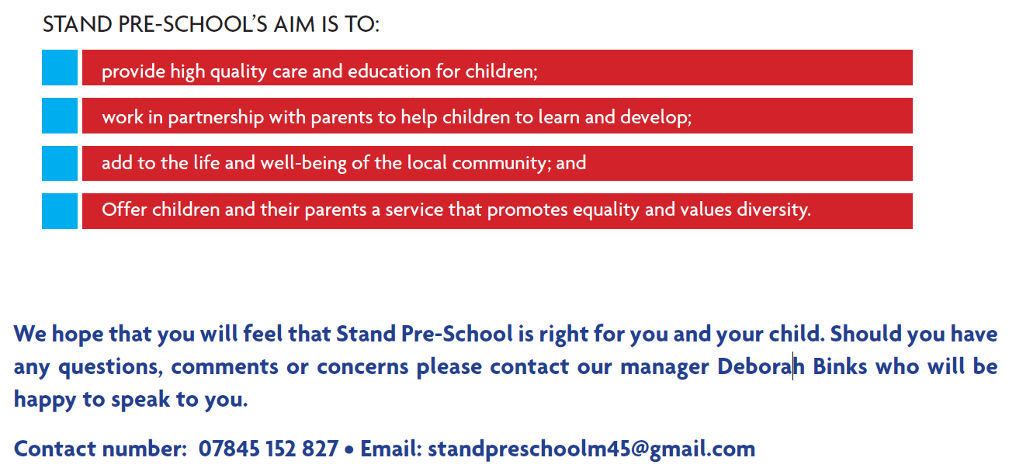
We provide care and education for children between the ages of two and five years.

Admission & Sessions
Stand Pre-School have always been very flexible to meet parents needs in terms of the different sessions we offer. Your child may attend half day sessions, a half day with lunch or full days. There is no minimum session requirement, although we would advocate a minimum of 3 sessions per week in order for your child to feel happy, settled and secure in their environment and most importantly, to build a positive relationship with staff and peers.
As access to Stand Pre School is via Higher Lane Primary School playground, we cannot have parents dropping off or picking up between 12pm and 1pm. Our offer of sessions has had to take this into consideration. We will however try to be as flexible as possible to meet parents needs.
Option 1 (Morning Session) – 9.00am-11.15am
Option 2 (Afternoon Session) – 1.15pm – 3.30pm
Option 3 (Afternoon Session including lunch) – 11.30am-3.30pm
Option 4 (Full Day) – 9.00am-3.30pm
Breakfast Club/Out of School Club
Higher Lane Primary School is now able to offer Stand Pre-School children age 3/4 places in their Breakfast and After School Club.

PRICE LIST 2021 -2022

Contracted Places.
Breakfast Club – 7.45am – 9.00am = £6.50
After School Club - 1 Hour session - 3.30pm to 4.30pm = £6.50
After School Club - Full session - 3.30pm to 6.00pm = £9.00

Occasional Bookings
Breakfast Club – 7.45am – 9.00am = £7.50
After School Club – 3.30pm-6.00pm = £11.00
1hour sessions are not available for occasional bookings.

For further information please email the club at osc.higherlane@visionmat.com

NAME | JOB TITLE | QUALIFICATIONS
Deborah Binks | Pre-School Manager  SENCO | Level 3 Diploma in Childcare and Education.  Level 2 in Leadership & Management
Carol Dunn | Deputy Manager  Room Leader  Designated Safeguarding Officer | NVQ Level 3 in Childcare and Education for Early Years.
Joanne Beaumont | Pre-School Practitioner  Behavioural Leader | NVQ 3 in Children’s and Young People’s Workforce
Susan Cleary | Pre-School Practitioner  Health & Safety Officer | NVQ 3 in Children Care, Learning and development
Claire Ball | Pre-School Practitioner | NVQ 2 in Children’s and Young People’s Workforce
Christine Phillipson | Pre-school Practitioner | NVQ 2 in Childcare and Education for Early Years
